Web Design and Development 4COSC011C.3

Report

Author: Nadil Nemitha Kaluarachchi

w2084392

Group Number: B09 Group Name: Life Under Water

Student Role: Student 2

Link(s) to Website

URL:

Table of Contents

1.Introduction 3

1.1 Team Members and Task Allocation 3

1.2 Website topic/theme 4

1.3 Contributions 4

2. Technical Discussion 5

2.1 Implementation 5

3. Webpage Validation Statement. 8

4. Janet 8

5. Self-Reflection 8

**State what skills you gained/learnt from undertaking the project.** 9

**State any strengths about yourself that emerged whilst undertaking the project.** 9

**State any weaknesses about yourself that emerged whilst undertaking the project.** 9

References 9

Appendices 10

Appendix A: Code 10

Appendix B: Screenshots 32

Appendix C: Screenshots - Webpage Validation Evidence 38

# 1.Introduction

The "Marine Minds" project is a bold and comprehensive initiative dedicated to raising awareness about the urgent need to protect and conserve ocean life, which plays a crucial role in maintaining the balance of Earth's ecosystems. By integrating technology, advocacy, and community involvement, the project addresses the pressing challenges faced by our oceans today.

Central to the "Marine Minds" project is an engaging web platform that leverages multimedia elements, including videos and images, to highlight the beauty and importance of ocean life. Visitors to the website can immerse themselves in stunning visuals and captivating narratives that underscore the significance of advocating for the health and sustainability of our oceans.

Education and empowerment are key pillars of the project. By providing accessible information on ocean conservation and illustrating the impact of human activities on marine ecosystems, "Marine Minds" seeks to inspire action among individuals, communities, and policymakers globally. The goal is to foster a sense of stewardship and accountability towards our oceans, driving collective efforts to protect marine biodiversity and habitats.

The project also includes interactive features, such as a shopping cart, to enhance user engagement and offer practical ways to support ocean conservation. Through a curated selection of eco-friendly products, "Marine Minds" promotes conscious consumerism, providing individuals with tangible opportunities to contribute to marine conservation.

In essence, the "Marine Minds" project adopts a holistic approach to safeguarding marine life. By harnessing technology, education, and community mobilization, the project aims to create a wave of awareness, advocacy, and action. Ultimately, "Marine Minds" aspires to secure a sustainable future for our oceans and the diverse species they harbor, ensuring the delicate balance of our planet's ecosystems is maintained for generations to come.

## 1.1 Team Members and Task Allocation

|  |  |  |
| --- | --- | --- |
| Name | Student Role | Task Allocated |
| Isumi Benara | Student 1 | Shop, Splash Screen, Page  Editor, Content Page |
| Nadil Nemitha | Student 2 | Navigation Bar, Feedback, Homepage, Page Editor,  Content Page |
| Warsha Diwyanjali | Student 4 | Sitemap, Gallery, Page  Editor, Content Page |

## 1.2 Website topic/theme

Life Below Water

## 1.3 Contributions

| **Group Coursework Meetings** (minimum 5 meetings, e.g., one per week) | | |
| --- | --- | --- |
| **1** | **Date & Tim**e | 26/06/2024 |
| **Objective:** | Choosing a topic and role allocation for every members in the group, and discuss the problem of having only 3 students in our group to manage all work properly. |
| **Attended:** | Full team participation |
| **Your Contribution:** | Shared ideas for topic selection |
| **2** | **Date & Time:** | 29/06/2024 |
| **Objective:** | Progress review and Theme finalization |
| **Attended:** | Full team participation |
| **Your Contribution:** | Collaborated on selecting color palettes, overall images, and typography choices. |
| **3** | **Date & Time:** | 03/07/2024 |
| **Objective:** | Progress check and Feedback exchange among members. |
| **Attended:** | Full team participation |
| **Your Contribution:** | Presented ongoing work and received constructive feedback. |
| **4** | **Date & Time:** | 07/07/2024 |
| **Objective:** | Quality assurance and Error resolution of codings |
| **Attended:** | Full team participation |
| **Your Contribution:** | Assisted in resolving issues and optimizing website performance. |
| **5** | **Date & Time:** | 17/07/2024 |
| **Objective:** | Integration and Final review of website |
| **Attended:** | Full team participation |
| **Your Contribution:** | Actively participated in linking web pages and conducting final inspections. |

# 2. Technical Discussion

## 2.1 Implementation

**Home Page.html**

The HTML code creates a webpage for "Marine Minds," showcasing various sections such as navigation, image slider, main content, about us, contact form, and footer. The <head> section includes the stylesheet styles.css and JavaScript file javaScript.js. The navigation bar at the top features a logo and menu links for different pages. The main container holds an image slider with three slides. The main content section introduces "Marine Minds," highlighting its mission to explore and protect marine life. The "About Us" section provides information about the organization's goals and efforts in marine conservation, accompanied by an image. The "Get in Touch" section includes a feedback form where users can submit their name, email, first-time visit status, website navigation feedback, suggestions for improvements, satisfaction rating, recommendation status, interest in receiving updates, and additional questions or requests. The form also features "Preview" and "Submit" buttons, each triggering a popup upon clicking. The footer at the bottom of the page includes copyright information, links to the page editor and content page, and social media icons for Facebook, Instagram, and Twitter. The code is structured to provide an informative and interactive user experience while promoting marine conservation awareness.

**Home Page.css**

The CSS code styles the "Marine Minds" webpage, defining global styles, layout, and animations for various elements. The universal selector * resets margins, padding, and box-sizing for all elements, ensuring consistency. The body is set to a light blue background with hidden horizontal overflow. The navigation bar .top features a fixed position, dark background, rounded bottom corners, and shadow, with the logo floated left and menu items aligned right. Menu links change color and underline on hover. The .container holds an image slider with three slides, each styled to cover the viewport, with background images and smooth transition effects. The .slide class sets initial position and opacity, and .slide.active brings the active slide into view with full opacity.

The .main-content and its children (h1 and p) are centered and positioned in the middle of the viewport, with white text. The .about-us section includes a heading and a paragraph, both styled for readability, and an image positioned to the right with rounded corners. The .contact section contains a feedback form, centrally aligned with various input fields and text areas styled for user interaction. Buttons #btn and #btn1 have specific styles and hover effects for visual feedback.

Popups .popup and .popup1 are hidden by default, styled with rounded corners, centered positioning, and transitions for smooth visibility changes. The .open-popup and .open-popup1 classes trigger visibility and scale animations using keyframes popupOpen and popupClose, which animate the appearance and disappearance of the popups.

The footer section is styled with a slate gray background, centered white text, and links that underline on hover. Social media icons are included, sized appropriately, and margin adjustments for spacing. Overall, the CSS ensures a visually appealing, user-friendly interface with interactive elements and smooth transitions, enhancing the user's experience on the "Marine Minds" website.

**Home Page.js**

This JavaScript code enhances the "Marine Minds" webpage with interactive functionality. It first waits for the DOM to load, then initializes an image slider that automatically transitions between slides every three seconds. The showSlide function displays the current slide by adding the "active" class, while nextSlide updates the current slide index cyclically. Additionally, the code handles form interactions, capturing user inputs and displaying a preview in a popup when the "Preview" button is clicked. The fun1 function prevents form submission, gathers input values (like name, email, and survey responses), and formats them for the preview. The form's submit event is also intercepted to validate inputs using the validate function, ensuring all required fields are filled. If validation passes, another popup appears, and the form is cleared. Two popup management functions, openPopup and closePopup, control the visibility of the preview and submission popups, toggling their respective classes. Event listeners are attached to buttons for previewing, submitting, and closing the popups. The validate function checks for non-empty inputs and selected options, alerting the user if any fields are incomplete. This script ensures smooth slide transitions, interactive previews, and form validation for a better user experience.

**Page Editor.html**

This HTML code creates an "Editor Page" with a structured layout using linked CSS styles. The page includes a header with the title "Page Editor" and personal details about the editor, Nadil Kaluarachchi. It lists the pages edited by Nadil, including the Home Page, Feedback, and Content Page, with brief descriptions of each and links to navigate back to these pages. The layout is divided into a left section with an image and a right section with the text content. Each section has headings, paragraphs, and horizontal rules for separation, enhancing readability and organization. The design employs HTML for structure and CSS for styling.

**Page Editor.css**

This CSS code styles the "Editor Page" HTML. It sets the overall page background color to a light blue (#f0f8ff) and uses white text. The .left img selector styles an image to cover the entire viewport width and height with reduced brightness. The .right section is positioned absolutely, with rounded corners, centered on the page, and contains text-aligned headers and paragraphs. The p elements in .home, .feedback, and .content sections have left and right margins for consistent padding. The #back1, #back2, and #back3 elements are styled with centered, larger text and no underline. The #backA1, #backA2, and #backA3 links are green, and their hover state underlines the text.

**Content Page.html**

This HTML page titled "Content Page" explores the impacts of coastal development, tourism, and maritime pollution on marine ecosystems. It features structured sections with descriptive text and relevant images (image1.webp and image2.jpg). Each section addresses specific environmental challenges and emphasizes the importance of sustainable practices and conservation efforts. The page concludes with a navigation link (Back to Home Page) for user convenience.

**Content Page.css**

This CSS code styles an HTML page featuring two sections (top and below) with images and paragraphs (p1 to p4). Images image1 and image2 are positioned with specific dimensions and rounded corners, complemented by drop shadows. Headings (h1) are centered, and spans (span) within headings are enlarged for emphasis. Margins and alignments (margin-left, margin-top) are used to organize content, ensuring readability and aesthetic appeal. Additionally, a navigation link (Back to Home Page) is styled for user interaction, enhancing accessibility and visual clarity with hover effects.

# 3. Webpage Validation Statement.

When I first validate, I get some errors then I resolve them. Again, I validate Home Page, Content Page, Editor page and all of them were free of errors. I validate my pages using and online validator called “validator.w3.org”. You can find the screenshot of the validation on appendix C.

# 4. Janet

The Janet network serves as a vital link for the UK's educational and research institutions, upholding stringent security measures. As the website supervisor, I guarantee that "Marine Minds" adheres to these JANET standards. Group 18 independently developed the website, ensuring the name and logo are original and free from external influences. To avoid legal issues, we carefully selected all photographs from non-copyrighted sources and will provide proper attribution for all used content.

# 5. Self-Reflection

**State what you learnt about teamwork.**

Throughout the project, I have learned the importance of assigning the most relevant roles to the team members and the significance of effective communication.

### **State what skills you gained/learnt from undertaking the project.**

Through this project, I have honed my skills in communication, leadership, teamwork, and time management, as well as my expertise in both front-end and back-end web development.

### **State any strengths about yourself that emerged whilst undertaking the project.**

I have discovered my strengths in personal discipline and both front-end and back-end development. Aspiring to become a full stack developer, this project has been immensely beneficial to me.

### **State any weaknesses about yourself that emerged whilst undertaking the project.**

If I had the opportunity to do this project again, I would improve my time management skills.

# References

Anon., n.d. JavaScript Function call(). [Online]

Available at: https://[www.w3schools.com/js/js_function_call.asp](http://www.w3schools.com/js/js_function_call.asp) [Accessed 13 07 2024].

Anon., n.d. JavaScript if, else, and else if. [Online] Available at: https://[www.w3schools.com/js/js_if_else.asp](http://www.w3schools.com/js/js_if_else.asp) [Accessed 09 07 2024].

Anon., n.d. JavaScript Reserved Words. [Online]

Available at: https://[www.w3schools.com/js/js_reserved.asp](http://www.w3schools.com/js/js_reserved.asp) [Accessed 10 07 2024].

Anon., n.d. freepik. [Online]

Available at: https://[www.freepik.com/](http://www.freepik.com/) [Accessed 14 07 2024].

# Appendices

## Appendix A: Code

**Home Page.html**

<!DOCTYPE html>

<html lang="en">

    <head>

        <link rel="stylesheet" href="styles.css">

        <script src="javaScript.js"></script>

        <title>MARINE MINDS</title>

        <meta charset="UTF-8">

    </head>

    <body>

        <div class="top">

            <img src="MARINEMINDSLOGO.png" alt="logo">

            <ul>

                <li><a href="#">Home</a></li>

                <li><a href="#">Team</a></li>

                <li><a href="gAllery.html">Gallery</a></li>

                <li><a href="shop.html">Shop</a></li>

                <li><a href="sitemap.html">Sitemap</a></li>

                <li><a href="#">User Profile</a></li>

                <li><a href="#detailslink">Feed Back</a></li>

            </ul>

        </div>

        <div class="container">

            <div class="slide slide-1"></div>

            <div class="slide slide-2"></div>

            <div class="slide slide-3"></div>

        </div>

        <div class="main-content">

            <h1>Welcome to Marine Minds</h1>

            <p>Explore and protect the ocean's depths with Marine Minds, <br>showcasing marine life's wonders like coral reefs and sea creatures,

                <br>while understanding, appreciating, and protecting our ecosystems.</p>

        </div>

        <div class="about-us">

            <h1>About Us</h1>

            <p>Our organization is dedicated to exploring and protecting the diverse life that thrives beneath the waves.

                Through engaging and informative content, we aim to raise awareness about the importance of marine ecosystems.

                Our team of passionate experts understands the critical need for conservation and works tirelessly to promote initiatives that

                safeguard our oceans. We believe in creating a connection between people and the underwater world, inspiring a global community to

                take action in preserving these vital habitats for future generations.</p>

            <img src="about-us.jpg" id=about-usImage alt="about-usimage">

        </div>

        <div class="contact">

            <h1  id="detailslink">Get in Touch</h1>

            <p id="here">We'd love to hear from you! Whether you have questions about our products,

                <br>want to learn more about our conservation efforts, or are interested in getting involved,

                feel free to reach out. </p>

            <form>

                <div class="feedback"></div>

                <div class="details">

                    <h3>Feedback Form</h3>

                    <label for="name">Enter your name: </label>

                    <input type="text" id=name name="Name" placeholder="Enter Name" required><br>

                    <label for="email">Enter your email: </label>

                    <input type="email" id="email" name="email" placeholder="Enter Email" required>

                    <p>Was this your first time visiting?</p><br>

                    <label for="visiting">Yes</label>

                    <input type="radio" id="visiting" name="visit" value="Yes" required>

                    <label for="no">No</label>

                    <input type="radio" id="no" name="visit" value="No">

                    <p>Was this website informative and easy to navigate through?</p><br>

                    <label for="easy">Yes</label>

                    <input type="radio" id="easy" name="easy" value="Yes" required>

                    <label for="Neasy">No</label>

                    <input type="radio" id="Neasy" name="easy" value="No">

                    <p>If "No",suggest any improvements for the future:</p><br>

                    <textarea required placeholder="Add your message here..." id="textarea"></textarea><br><br>

                    <p>How satisfied are you with Our services? Choose from 0 to 10, with 1 being

                        <br>"Not satisfied at all!" and 10 being "Extremely satisfied!"</p><br>

                    <div class="radiobtn">

                        <label for="1">1</label>

                        <input type="radio" id="1" name="stars" value="1" class="input"  required>

                        <label for="2" class="label">2</label>

                        <input type="radio" id="2" name="stars" value="2" class="input">

                        <label for="3" class="label">3</label>

                        <input type="radio" id="3" name="stars" value="3" class="input">

                        <label for="4" class="label">4</label>

                        <input type="radio" id="4" name="stars" value="4" class="input">

                        <label for="5" class="label">5</label>

                        <input type="radio" id="5" name="stars" value="5" class="input">

                        <label for="6" class="label">6</label>

                        <input type="radio" id="6" name="stars" value="6" class="input">

                        <label for="7" class="label">7</label>

                        <input type="radio" id="7" name="stars" value="7" class="input">

                        <label for="8" class="label">8</label>

                        <input type="radio" id="8" name="stars" value="8" class="input">

                        <label for="9" class="label">9</label>

                        <input type="radio" id="9" name="stars" value="9" class="input">

                        <label for="10" class="label">10</label>

                        <input type="radio" id="10" name="stars" value="10" class="input">

                    </div><br>

                    <p>Would you recommend our services?</p><br>

                    <label for="Y">Yes</label>

                    <input type="radio" name="RY" id="Y" value="Yes" required>

                    <label for="N">No</label>

                    <input type="radio" name="RY" id="N" value="No"><br>

                    <label for="offers">Would you like to recieve updates about the website and any offers?</label><br><br>

                    <select id="offers" name="offers">

                        <option value="Yes-via Email">Yes-via Email</option>

                        <option value="No">No</option>

                    </select><br><br>

                    <label for="additional">Do you have additional questions or requests?</label><br><br>

                    <textarea id="additional" name="additional" placeholder="Add your message here..."  required></textarea><br>

                    <button type="button" name="preview" id="btn1" onclick="openPopup()">Preview</button>

                    <button type="submit" name="send" id="btn" onclick="openPopup1()">Submit</button>

                </div>

            </form>

            <P><br><br></P>

        </div>

        <div class="popup" id="popup">

            <h2>Details</h2>

            <p class="output" id="output1"></p>

            <input type="button" id="btnOK" value="Ok">

        </div>

        <div class="popup1" id="popup1">

            <img src="tick.webp" alt="tickimg">

            <h2>Thank You!</h2>

            <p>Your details has been successfully submitted. Thanks!</p>

            <input type="button" id="btnOK1" value="Ok">

        </div>

        <footer>

            <p id="fot">&copy; 2024 My Website. All rights reserved.</p>

            <p><a href="pageeditor.html">Page Editor</a> | <a href="contentPage.html">Content Page</a></p>

            <p>Follow Us</p>

            <a href="https://www.facebook.com/"><img src="facebook.png" alt="facebookimage"></a>

            <a href="https://www.instagram.com/"><img src="instergram.png" alt="instergramimage"></a>

            <a href="https://www.twitter.com"><img src="twitter.png" alt="twitterimage"></a>

        </footer>

    </body>

</html>

**Home Page.css**

*{

    margin: 0;

    padding: 0;

    font-family:sans-serif;

    box-sizing: border-box;

}

body{

    overflow-x: hidden;

    background-color: #87CEEB;

}

.top img{

    float:left;

    width:12%;

    padding-left: 60px;

    padding-top: 18px;

}

.top ul{

    margin-left: 43%;

    padding-top: 2%;

}

.top ul li a:after{

    content:"";

    position:absolute;

    left:0px;

    background-color: white;

    height:3px;

    width:0%;

    bottom:-8px;

    transition: 0.3s;

}

.top ul li a:hover::after{

    width:100%;

}

.top ul li a{

    position: relative;

    display: inline;

    list-style-type: none;

    text-decoration: none;

    margin-right: 20px;

    padding-right: 5px;

    padding-left: 5px;

    color:#FAEBD7;

    outline:none;

}

.top ul li a:hover{

    color:white;

}

.top{

    background-color: rgb(20, 84, 100);

    height:12%;

    width: 100%;

    position: fixed;

    z-index:1;

    box-shadow: 10px;

    border-bottom-left-radius: 60px;

    border-bottom-right-radius: 60px;

}

.top ul li{

    display: inline;

    font-weight: bold;

    font-size: 130%;

    color: rgb(255, 255, 255);

}

.container{

    position:relative;

    width:100vw;

    height: 100vh;

    overflow: hidden;

    background-color: aqua;

    filter:brightness(20%)

}

.slide-1{

    background-image: url("background1.png");

    background-attachment: fixed;

}

.slide-2{

    background-image: url("background2.png");

}

.slide-3{

    background-image: url("background3.png");

}

.slide{

    width: 100%;

    height: 100vh;

    background-size: cover;

    background-position: center;

    position: absolute; /* Make slides overlap each other */

    top: 0;

    left: 100%; /* Start offscreen to the right */

    opacity: 0;

    transition: background-image 1s ease-in-out; /* Smooth transition for opacity and position */

}

.slide.active {

    left: 0; /* Move active slide into view */

    opacity: 1; /* Fully visible */

}

.main-content,h1,p{

    text-align: center;

}

.main-content{

    left:430px;

    position: absolute;

    top: 50vh;

    color: white;

}

.main-content h1{

    font-family:Verdana, sans-serif;

    font-size: 50px;

}

.about-us{

    position:relative;

    top:50px;

}

.about-us h1{

    font-size: 40px;

}

#about-usImage{

    position: absolute;

    margin-top: -280px;

    left: 800px;

    border-radius: 50px;

}

.about-us p{

    font-size: 20px;

    padding-top: 90px;

    padding-left: 200px;

    width:700px;

    text-align: justify;

}

.contact h1{

    margin-top: 230px;

}

#here{

    margin-top: 20px;

}

.feedback{

    width:800px;

    height:870px;

    margin-left: 25%;

}

.details{

    color:black;

    text-align: center;

    width:400px;

    position: absolute;

    margin-top: -818px;

    margin-left: 28.3%;

    width: 700px;

    background-color: white;

    border:4px solid #4682B4;

    border-radius: 30px;

}

.contact h3{

    padding-top: 20px;

    padding-bottom: 20px;

    font-size: 25px;

}

.details input{

    margin-left: 30px;

    margin-bottom: 20px;

    outline: none;

    border: none;

    border-bottom: 3px solid black;

}

.details textarea{

    margin-left: 30px;

    width:365px;

    outline: none;

    border: none;

    border-bottom: 3px solid black;

}

#btn{

    margin-left: 200px;

    margin-top: 30px;

    width: 90px;

    height: 30px;

    font-size: 15px;

    font-weight: bold;

    border: none;

    background-color: aqua;

    cursor: pointer;

    border-radius: 10px;

    margin-bottom: 40px;

}

#btn1{

    margin-bottom: 40px;

    margin-left: 30px;

    margin-top: 30px;

    font-weight: bold;

    width: 90px;

    height: 30px;

    font-size: 15px;

    border: none;

    background-color: aqua;

    cursor: pointer;

    border-radius: 10px;

}

.contact form{

    padding-top: 30px;

}

.radiobtn{

    display: flex;

    justify-content: space-between;

}

.radiobtn input[type="radio"] {

    display: block;

    margin: 5px auto 0;

}

.radiobtn label {

    display: block;

    text-align: center;

    font-size: 0.9em;

}

.popup{

    width: 400px;

    background-color: white;

    height: 300px;

    margin-left: 40%;

    border-radius: 20px;

    position: absolute;

    border:4px solid #4682B4;

    visibility: hidden;

}

.open-popup{

    visibility: visible;

}

.popup h2{

    padding-top: 20px;

    text-align: center;

    padding-bottom: 20px;

}

.popup p{

    text-align: justify;

    margin-left: 30px;

}

#btnOK{

    border-radius: 20px;

    position: absolute;

    top:250px;

    left:45%;

    width:60px;

    height: 30px;

    font-weight: bold;

    background-color: aqua;

    border: none;

    font-size: 15px;

}

#btnOK:hover{

    box-shadow: 0 0 5px cyan,

    0 0 25px cyan, 0 0 50px cyan, 0 0 100px cyan, 0 0 200px cyan;

}

#btn1:hover{

    box-shadow: 0 0 5px cyan,

    0 0 25px cyan, 0 0 50px cyan, 0 0 100px cyan, 0 0 200px cyan;

}

#btn:hover{

    box-shadow: 0 0 5px cyan,

    0 0 25px cyan, 0 0 50px cyan, 0 0 100px cyan, 0 0 200px cyan;

}

.popup1{

    margin-top: 30px;

    width: 400px;

    background-color: white;

    height: 250px;

    margin-left: 39.5%;

    border-radius: 20px;

    position: absolute;

    border:4px solid #4682B4;

    visibility: hidden;

}

.open-popup1{

    visibility: visible;

}

.popup1 h2{

    margin-top: 60px;

    margin-bottom: 30px;

    text-align: center;

}

.popup1 p{

    padding-left: 30px;

    padding-right: 30px;

}

.popup1 img{

    width:200px;

    position: absolute;

    margin-top: -70px;

    margin-left: 100px;

}

#btnOK1{

    border-radius: 20px;

    position: absolute;

    top:200px;

    left:45%;

    width:60px;

    height: 30px;

    font-weight: bold;

    background-color: aqua;

    border: none;

    font-size: 15px;

}

#btnOK1:hover{

    box-shadow: 0 0 5px cyan,

    0 0 25px cyan, 0 0 50px cyan, 0 0 100px cyan, 0 0 200px cyan;

}

.popup, .popup1 {

    visibility: hidden;

    opacity: 0;

    transform: scale(0.5);

    transition: visibility 0s, opacity 0.5s, transform 0.5s;

}

.open-popup, .open-popup1 {

    visibility: visible;

    animation: popupOpen 0.5s forwards;

}

.close-popup, .close-popup1 {

    animation: popupClose 0.5s forwards;

}

/* Pop-up Animations */

@keyframes popupOpen {

    0% {

        transform: scale(0.5);

        opacity: 0;

    }

    100% {

        transform: scale(1);

        opacity: 1;

    }

}

@keyframes popupClose {

    0% {

        transform: scale(1);

        opacity: 1;

    }

    100% {

        transform: scale(0.5);

        opacity: 0;

    }

}

footer{

    background-color: #708090;

    color: white;

    width:100vw;

    text-align: center;

    height:250px;

    margin-top: 80px;

}

footer a img{

    margin-top: 20px;

    width:2%;

}

footer a{

    color: white;

    text-decoration: none;

}

footer a:hover{

    text-decoration: underline;

}

#fot{

    margin-top: 40px;

}

footer p{

    padding-top: 40px;

}

#here{

    font-size: 20px;

}

**Home Page.js**

document.addEventListener("DOMContentLoaded", () => {

    let currentSlide = 0;

    const slides = document.querySelectorAll(".slide");

    const totalSlides = slides.length;

    function showSlide(index) {

        slides.forEach((slide, i) => {

            if (i === index) {

                slide.classList.add("active");

            } else {

                slide.classList.remove("active");

            }

        });

    }

    function nextSlide() {

        currentSlide = (currentSlide + 1) % totalSlides;

        showSlide(currentSlide);

    }

    setInterval(nextSlide, 3000); // Change image every 3 seconds

    showSlide(currentSlide); // Initially show the first slide

    const form = document.querySelector('form');

    const text3 = document.getElementById('name');

    const text4 = document.getElementById("email");

    const text7 = document.getElementById('textarea');

    const text10 = document.getElementById('offers');

    const text11 = document.getElementById('additional');

    const out3 = document.getElementById('output1');

    const btn3 = document.getElementById('btn1');

    const btnSubmit = document.getElementById('btn');

    function fun1(event) {

        event.preventDefault(); // Prevent form submission and page reload

        const text5 = document.querySelector("input[name='visit']:checked");

        const text6 = document.querySelector("input[name='easy']:checked");

        const text8 = document.querySelector("input[name='stars']:checked");

        const text9 = document.querySelector("input[name='RY']:checked");

        out3.innerHTML = `Name: ${text3.value}<br>Email: ${text4.value}<br>Visit: ${text5 ? text5.value : 'Not specified'}

        <br>Easy to navigate: ${text6 ? text6.value : 'Not specified'}<br>Improvements: ${text7.value}

        <br>Stars: ${text8 ? text8.value : 'Not specified'}<br>Do you recommend: ${text9 ? text9.value : 'Not specified'}

        <br>Like to receive updates: ${text10.value}<br>Additional requests: ${text11.value}`;

        openPopup(); // Open the preview popup

    }

    btn3.addEventListener('click', fun1);

    form.addEventListener('submit', function(event) {

        event.preventDefault();

        if (validate()) {

            openPopup1();

            clearForm();

        }

    });

    let popup = document.getElementById("popup");

    let popup1 = document.getElementById("popup1");

    function openPopup() {

        popup.classList.add("open-popup");

    }

    function closePopup() {

        popup.classList.remove("open-popup");

    }

    function openPopup1() {

        popup1.classList.add("open-popup1");

    }

    function closePopup1() {

        popup1.classList.remove("open-popup1");

    }

    function clearForm() {

        form.reset();

    }

    function validate() {

        let isValid = true;

        const text5 = document.querySelector("input[name='visit']:checked");

        const text6 = document.querySelector("input[name='easy']:checked");

        const text8 = document.querySelector("input[name='stars']:checked");

        const text9 = document.querySelector("input[name='RY']:checked");

        if (text3.value.trim() === '') {

            alert('Name is required');

            isValid = false;

        } else if (text4.value.trim() === '') {

            alert('Email is required');

            isValid = false;

        } else if (!text5) {

            alert('Please select an option for Visit');

            isValid = false;

        } else if (!text6) {

            alert('Please select an option for Ease of Use');

            isValid = false;

        } else if (!text8) {

            alert('Please select a rating for Stars');

            isValid = false;

        } else if (!text9) {

            alert('Please select an option for Recommendation');

            isValid = false;

        }

        return isValid;

    }

    document.getElementById('btnOK').addEventListener('click', closePopup);

    document.getElementById('btnOK1').addEventListener('click', closePopup1);

});

**Page Editor.html**

<!DOCTYPE html>

<html lang="en">

    <head>

        <title>Editor Page</title>

        <link rel="stylesheet" href="styles1.css">

    </head>

    <body>

        <div class="backColor"></div>

        <div class="container">

            <div class="left">

                <img src="image.jpg" alt="image1">

            </div>

            <div class="right1"></div>

            <div class="right">

                <h1>Page Editor</h1>

                <h3>Name: Nadil Kaluarachchi</h3>

                <h3>Role: Student 2</h3>

                <h3>The following pages were edited by me:</h3>

                <hr>

                <div class="home">

                    <h3>Home Page</h3>

                    <p>THe home indroduces the 'Lige Below Water' project, detailing our mission to protect marine ecosystems and raise awareness about ocean concervation. Created using HTML, CSS and JavaScript languages.</p>

                    <p id="back1"><a href="homePage.html" id="backA1">Back to Home Page</a></p>

                    <hr>

                </div>

                <div class="feedback">

                    <h3>Feed Back</h3>

                    <p>This section includes a feedback form for visitors to share their thoughts and suggestions about our project. Created using HTML, CSS and JavaScript languages.</p>

                    <p id="back2"><a href="homePage.html#here" id="backA2">Back to Feed Back Form</a></p>

                    <hr>

                </div>

                <div class="content">

                    <h3>Content Page</h3>

                    <p>Content page was implemented using HTML and CSS. It consists with topic related to marine life.</p>

                    <p id="back3"><a href="contentPage.html" id="backA3">Back to Content Page</a></p>

                </div>

            </div>

        </div>

    </body>

</html>

**Page Editor.css**

body {

    font-family: Arial, sans-serif;

    margin: 0;

    padding: 0;

    background-color: #f0f8ff;

    color: white;

}

.left img{

    width:100vw;

    height:110vh;

    filter:brightness(30%);

}

.right{

    position: absolute;

    border-radius: 30px;

    width:700px;

    left:30%;

    top:3%;

}

.right h1{

    text-align: center;

}

.home p{

    margin-left: 30px;

    margin-right: 30px;

}

.right h1,h3{

    text-align: center;

}

.feedback p{

    margin-left:30px;

    margin-right:30px;

}

.content p{

    margin-left: 30px;

    margin-right:30px;

}

#back1{

    font-size: 20px;

    text-align: center;

    margin-bottom:15px;

    text-decoration: none;

}

#back2{

    font-size: 20px;

    text-align: center;

    margin-bottom:15px;

    text-decoration: none;

}

#back3{

    font-size: 20px;

    text-align: center;

    margin-bottom:15px;

    text-decoration: none;

}

#backA1{

    text-decoration: none;

    color: rgb(172, 207, 58);

}

#backA2{

    text-decoration: none;

    color: rgb(172, 207, 58);

}

#backA3{

    text-decoration: none;

    color: rgb(172, 207, 58);

}

#backA1:hover{

    text-decoration: underline solid 3px;

}

#backA2:hover{

    text-decoration: underline solid 3px;

}

#backA3:hover{

    text-decoration: underline solid 3px;

}

**Content Page.html**

<!DOCTYPE html>

<html lang="en">

    <head>

        <title>Content Page</title>

        <link rel="stylesheet" href="content.css">

    </head>

    <body>

        <h1><i>Coastal Development and its Impact on Marine Ecosystems</i></h1>

        <div class="container">

            <div class="top">

                <img src="image1.webp" id="image1" alt="background">

                <div class="p1">

                    <h2><span>01.</span>Coastal Development</h2>

                    <p>Coastal development, driven by urbanization and infrastructure expansion, leads to habitat destruction and alters natural coastal dynamics. Key habitats like mangroves, salt marshes, and coral reefs are devastated, diminishing biodiversity and increasing coastal vulnerability to erosion and flooding. Additionally, runoff from developed coastal areas introduces pollutants into marine environments, compromising water quality and ecosystem health.</p>

                </div>

                <div class="p2">

                    <h2><span>02.</span>Tourism Effects</h2>

                    <p>Tourism poses a significant threat to marine life, causing physical damage to coral reefs and habitats, disrupting ecosystems through anchoring, snorkeling, and boat traffic, and contaminating coastal waters with marine litter, sewage discharge, and chemical pollutants. Unsustainable fishing practices, driven by tourism demand, further strain marine resources, leading to fish depletion and disrupting food chains. Therefore, sustainable tourism practices and effective management strategies are crucial to mitigate adverse effects on marine biodiversity and ecosystem integrity.</p>

                </div>

            </div>

            <div class="below">

                <img src="image2.jpg" id="image2" alt="background2">

                <div class="p3">

                    <h2><span>03.</span>Polution from Ships</h2>

                    <P>Marine ecosystems are severely impacted by pollution from ships and maritime activities. Oil spills, ballast water exchange, and emissions from ship exhausts cause long-term harm to marine mammals, seabirds, and coastal habitats. These pollutants disrupt native biodiversity and ecosystems. To minimize environmental impacts and protect marine biodiversity, strict regulations, effective enforcement, and technological innovations are needed.</P>

                </div>

                <div class="p4">

                    <h2><span>04.</span>Conservation and Sustainable Practives</h2>

                    <p>Human activities like coastal development, tourism, and maritime pollution pose a global threat to marine ecosystems, disrupting habitats, degrading water quality, and reducing marine biodiversity. Sustainable management practices, international cooperation, and public awareness are essential for mitigating these impacts and preserving marine environments for future generations. Adopting responsible policies can protect and conserve these valuable ecological, economic, and cultural benefits.</p>

                </div>

            </div>

        </div>

        <p id="back"><a href="homePage.html" id="backA">Back to Home Page</a></p>

    </body>

</html>

**Content Page.css**

body{

    top:0;

    padding:0;

    font-family:sans-serif;

}

img{

    position: absolute;

    width:500px;

    height: 400px;

    border-radius: 30px;

}

h1{

    text-align: center;

    font-size: 40px;

}

#image1{

    top:130px;

    left: 230px;

    box-shadow: 5px 5px 8px 5px #888888

}

#image2{

    top:680px;

    left:54%;

    box-shadow: 5px 5px 8px 5px #888888

}

.p1{

    margin-left: 50%;

    margin-top: 30px;

    width:500px;

}

.p2{

    margin-left: 50%;

    width:500px;

}

.p3{

    margin-left: 12%;

    width:500px;

    margin-top: -50px;

}

.p4{

    margin-left: 12%;

    width:500px;

}

.top{

    margin-bottom: 100px;

}

.below{

    margin-bottom: 50px;

}

span{

    font-size: 70px;

}

.container{

    margin-left: 70px;

}

#back{

    font-size: 20px;

    text-align: center;

    margin-bottom: 70px;

    text-decoration: none;

}

#backA{

    text-decoration: none;

}

#backA:hover{

    text-decoration: underline solid 3px;

}

## Appendix B: Screenshots

**Home Page Screenshots**

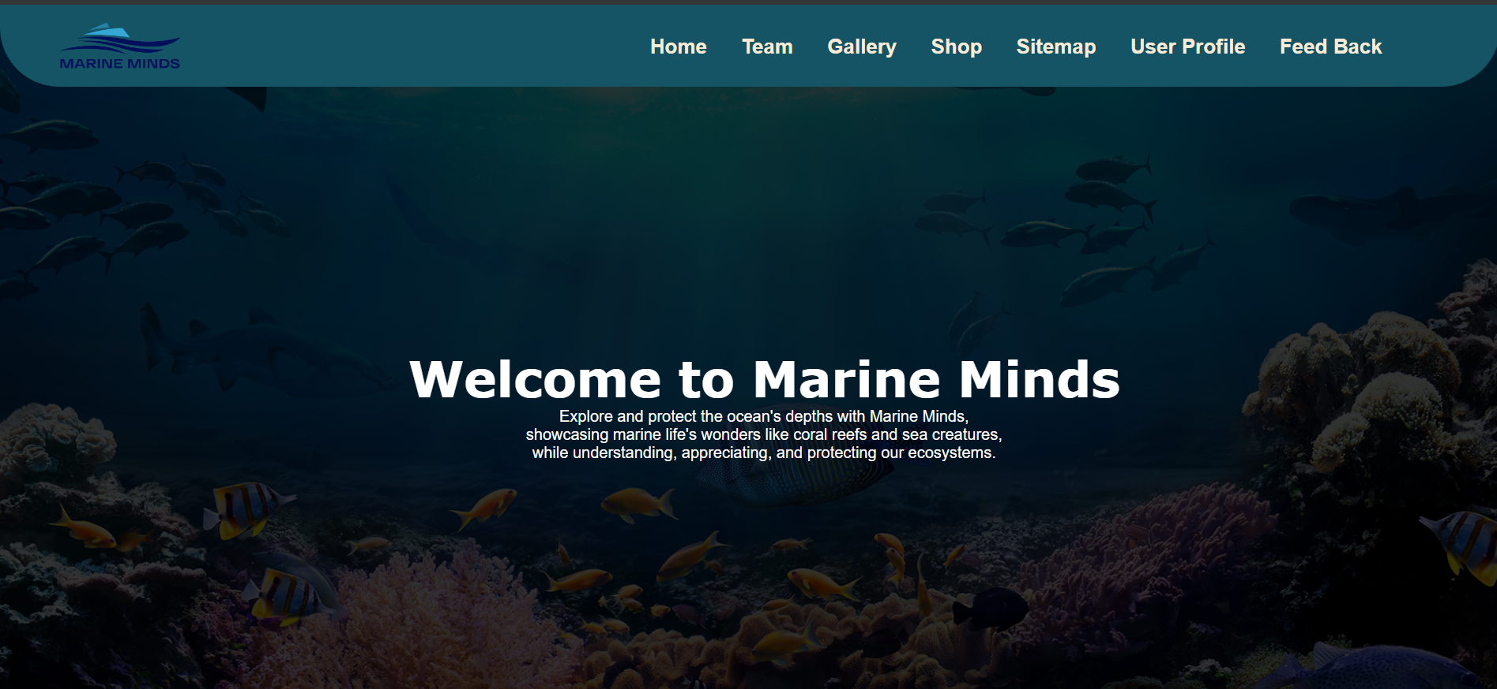

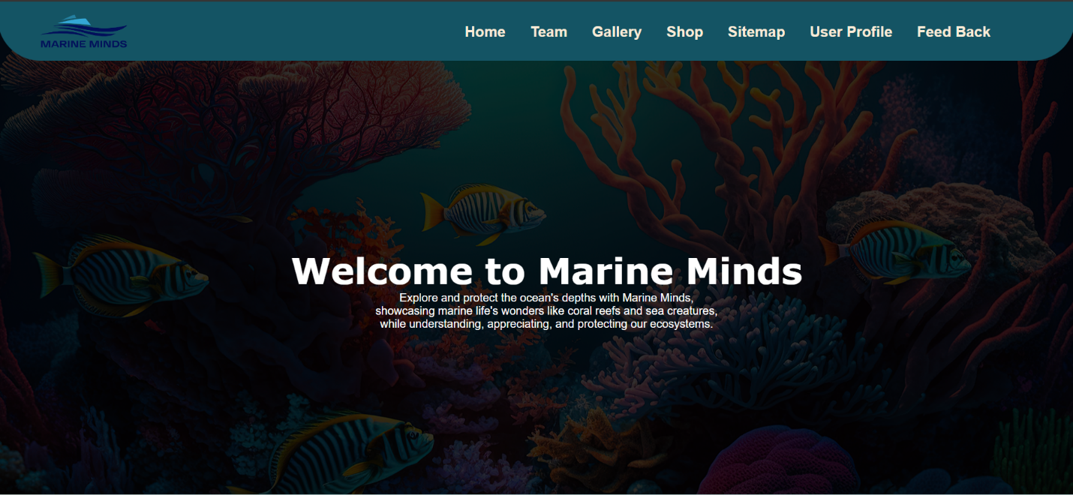

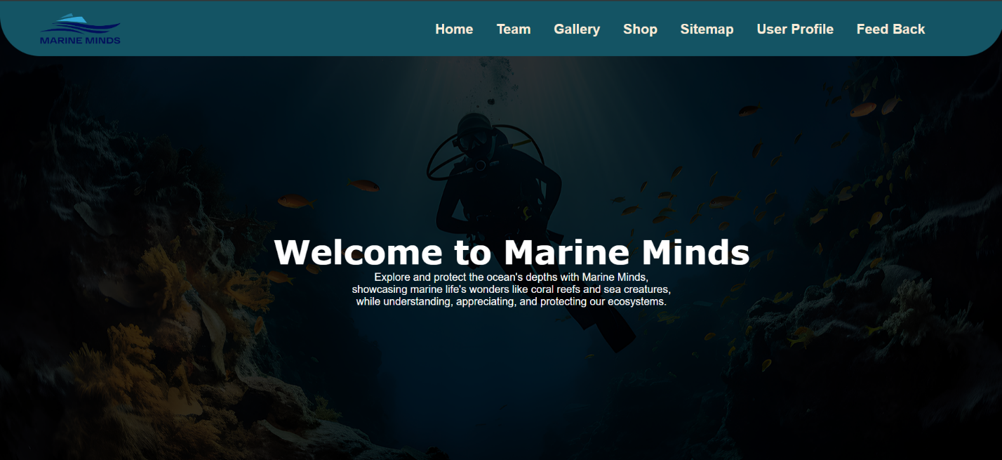

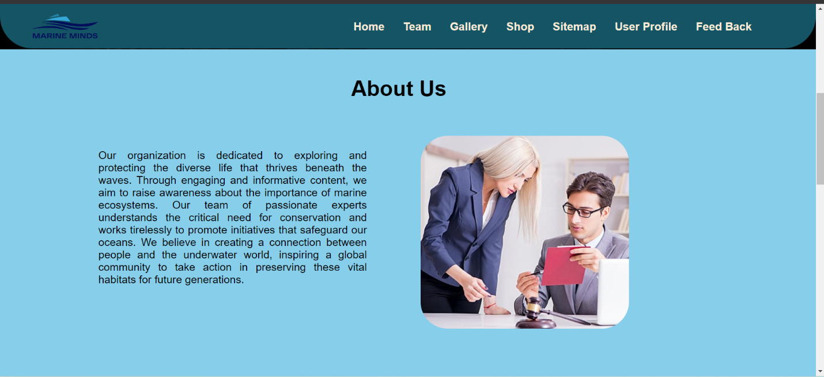

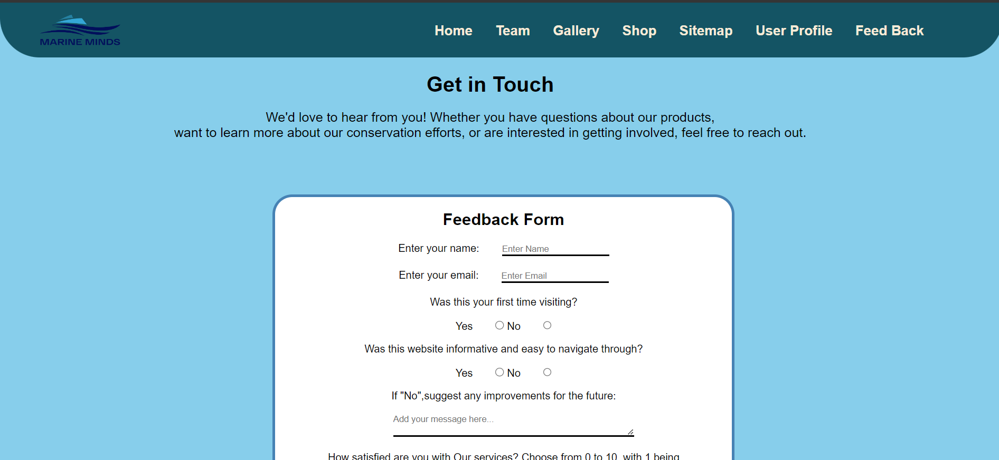

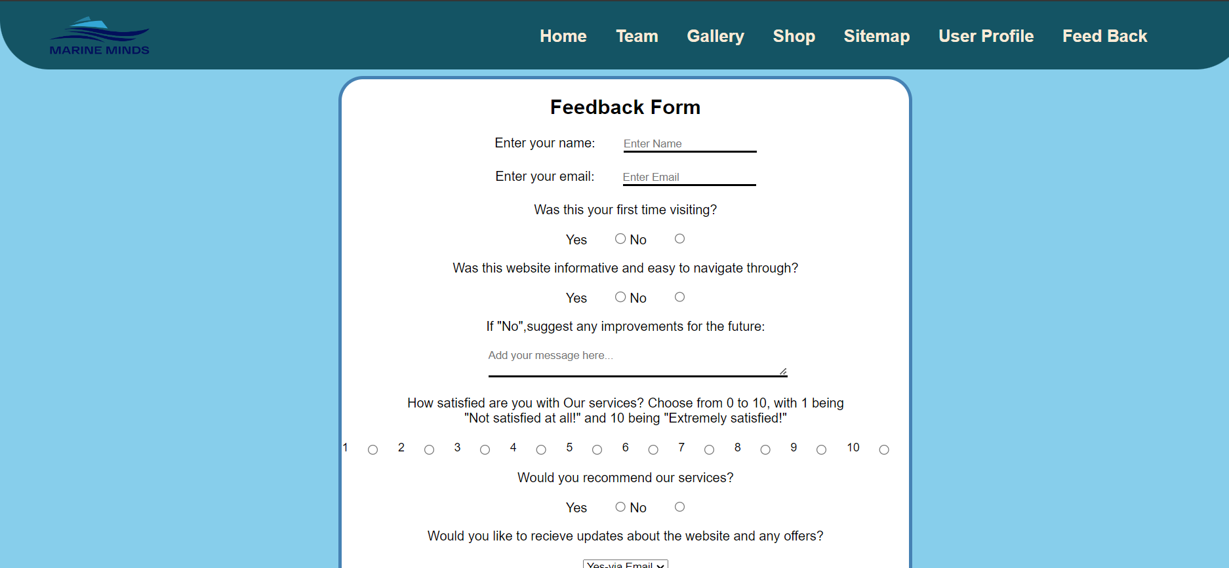

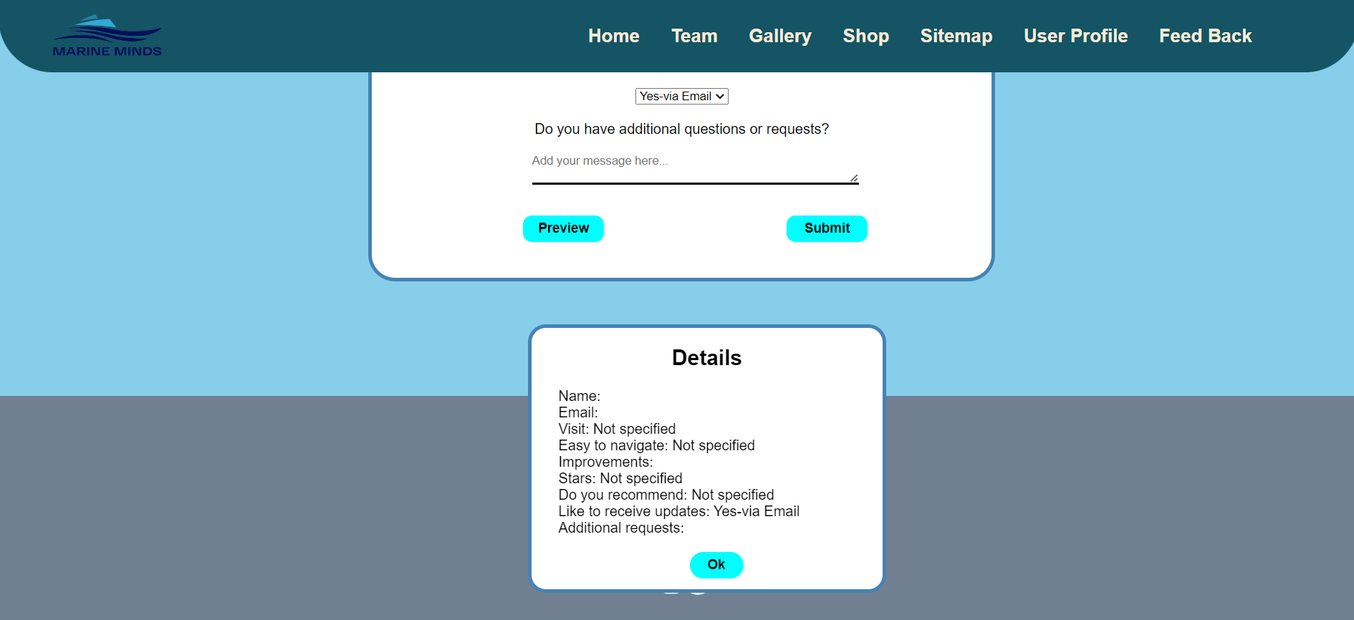





**Page Editor Screen Shots**

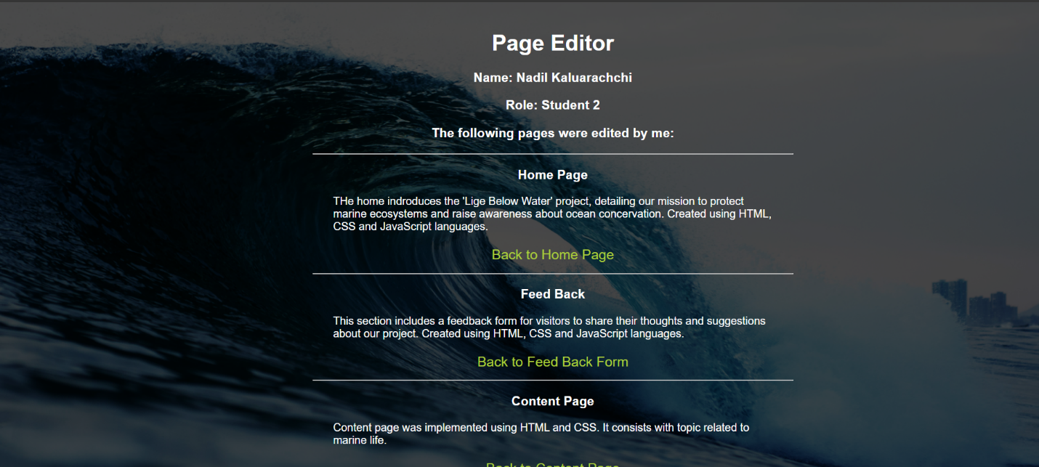



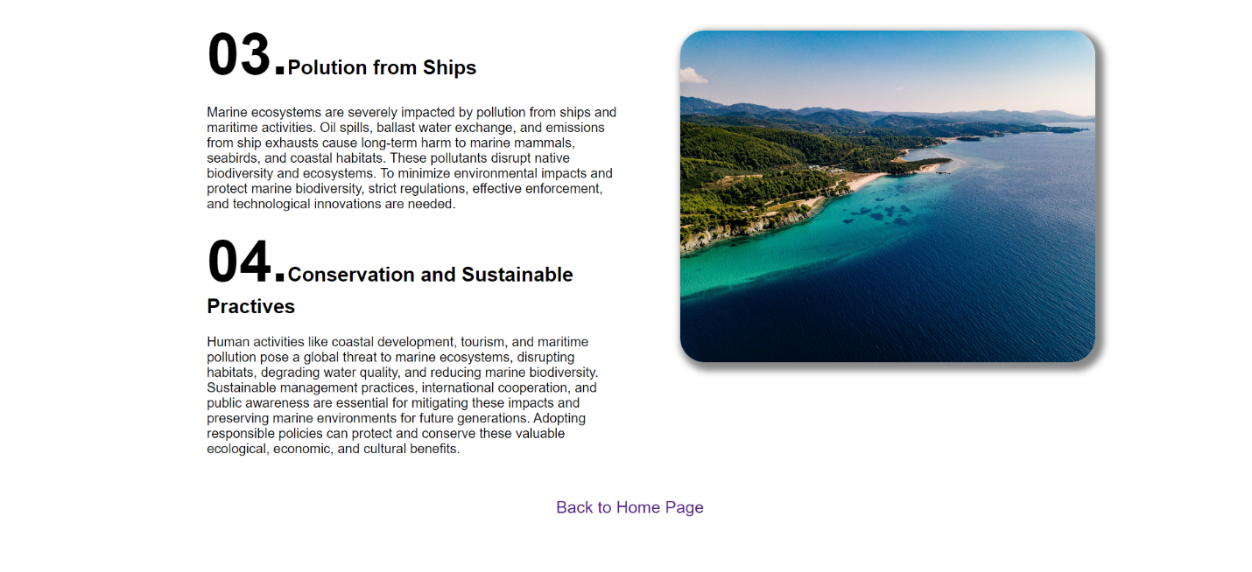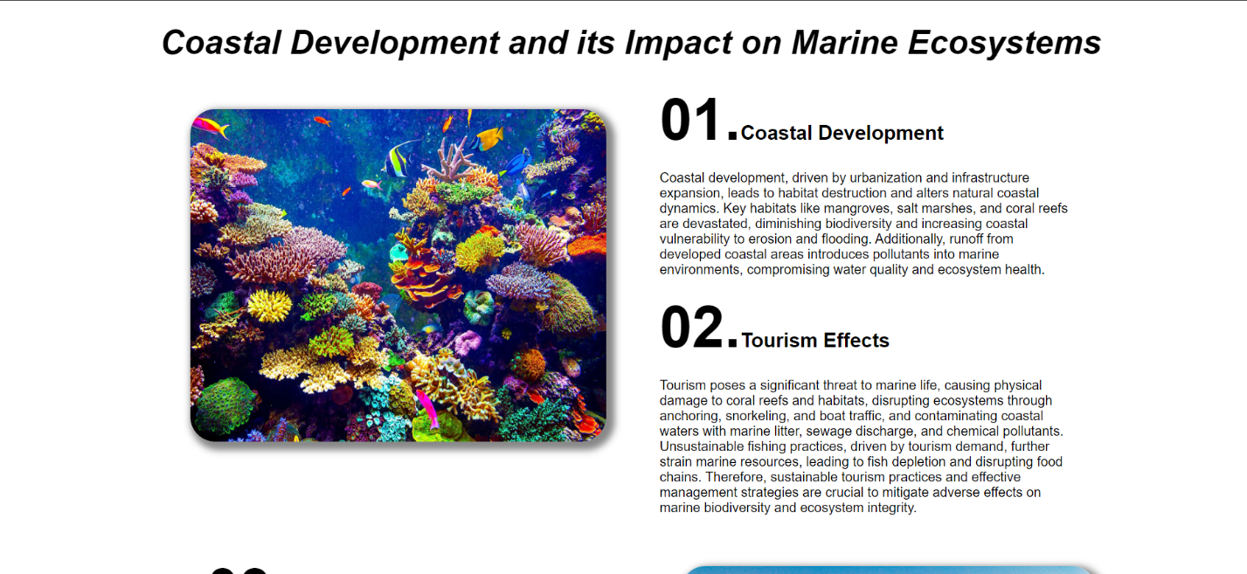**Content Page Screenshots**

## Appendix C: Screenshots - Webpage Validation Evidence

